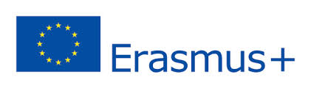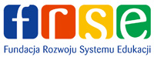

„THE VISION OF MODERN SCHOOL – CREATING
STUDENTS’ KEY COMPETENCIES"
22.04.2022 – 29.04.2022, Malta, Gozo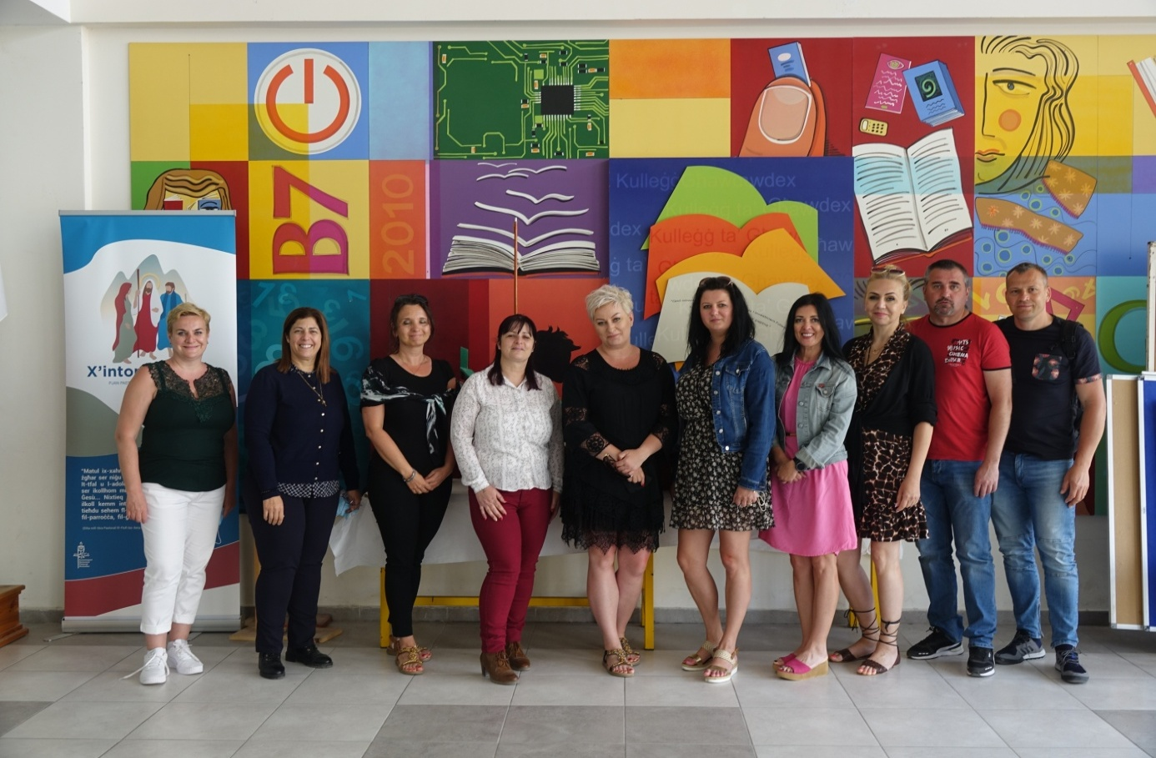
From 22/04/2022 to 29/04/2022, a group of 8 teachers from our school had the opportunity to participate in ERASMUS+ PROJECT - ACTION KA1 MOBILITY OF SCHOOL EDUCATION STAFF entitled "A vision of a modern school - creating students' key competences". The destination of the mobility was Malta and a partner institution was - Gozo College Secondary School.
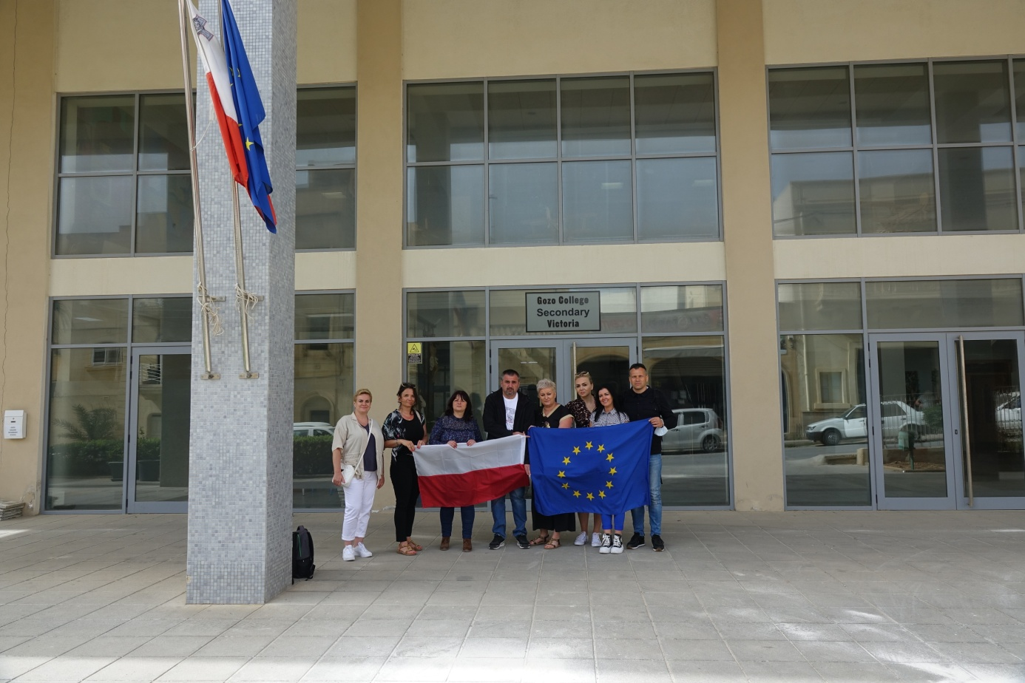
The activities at school were held as job shadowing and were of a varied nature. The choice of Gozo Secondary School was not accidental. It is a modern school facility for young people, which is characterized by a high level of teaching science, technology, vocational subjects, IT and foreign languages.
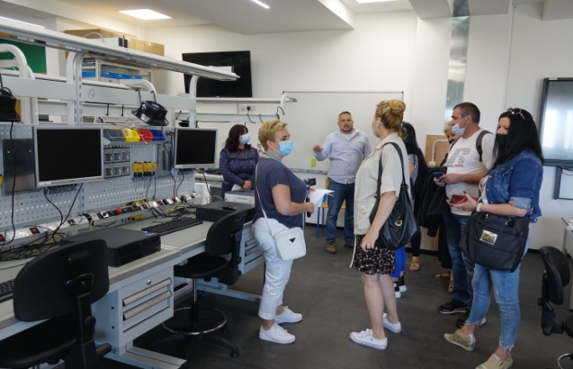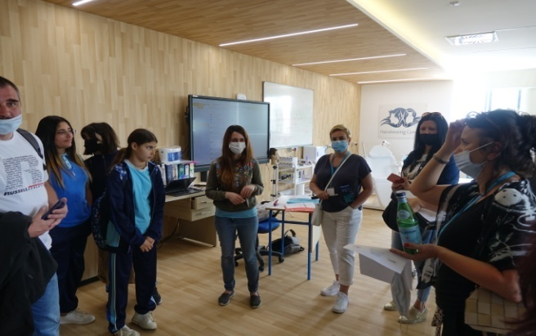
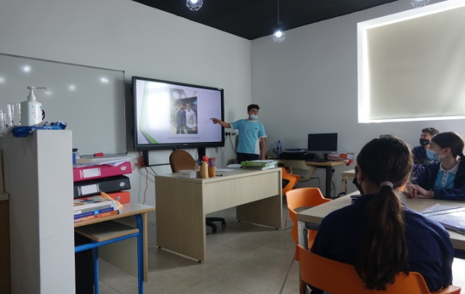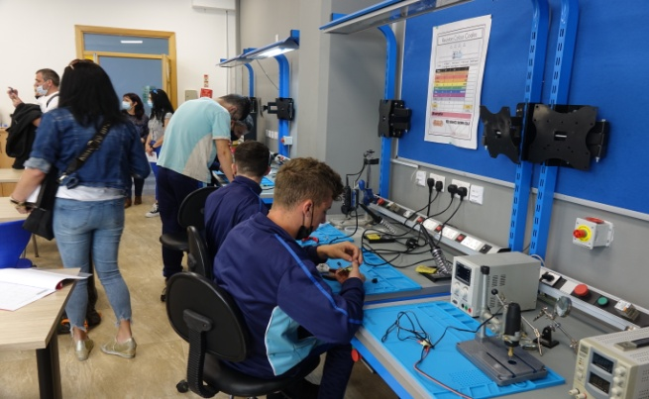
Modern and well-equipped laboratories, the use of various IT tools and multimedia programs enable the implementation of innovative methods in general education. They also allow to prepare the students for the future profession. The monitoring and recognizing the intellectual abilities of students correlates with the career counseling. That allows to identify the individual predispositions and talents of the coming labor market.
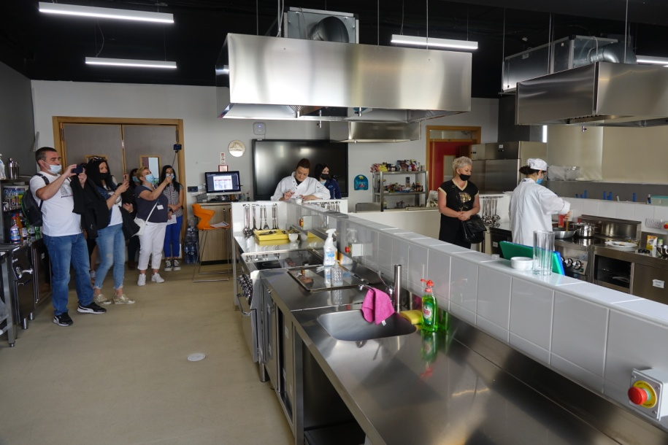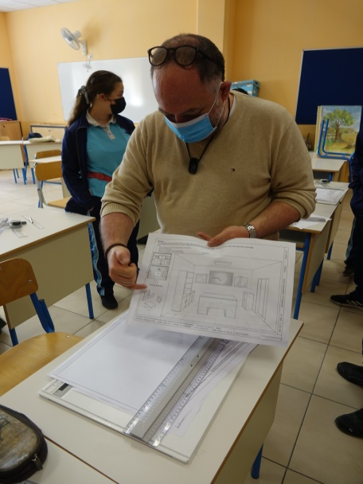
The next important detail, we could observe, is the structure of school activities that prepare students for real life. The classrooms used for this kind of activities were fully furnished and the lessons were addressed to students with special educational needs. We had also the possibility to see how the support teachers work and we learned the methods that they use to motivate and improve the students with disabilities.

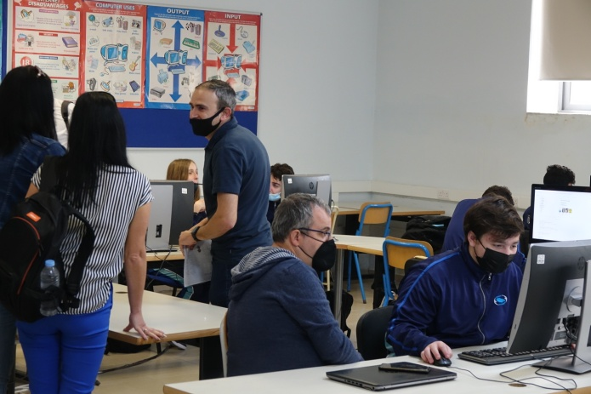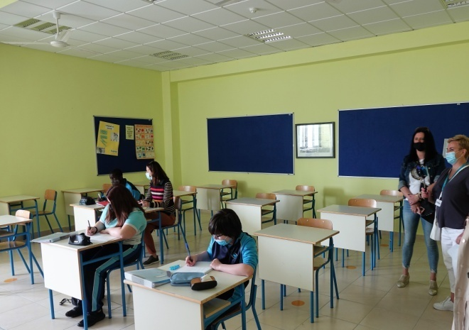
During the working meetings we were introduced to the Maltese education system. It was an opportunity to compare and reflect it with the Polish one. We also learned about modern and innovative methods of teaching and managing an educational institution. This allowed the main goal of the project to be achieved, which was to improve the quality of school work and in particular to create students' key competences.
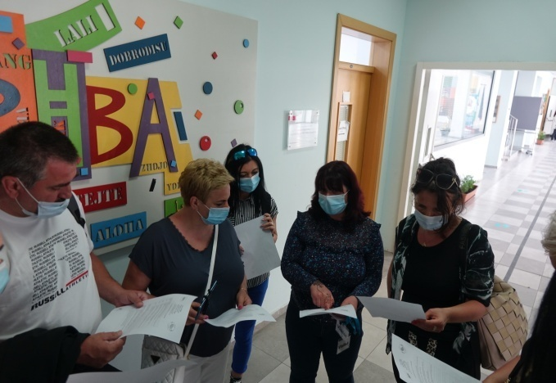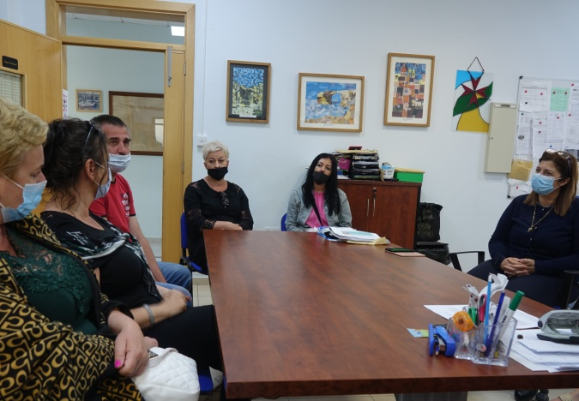

Currently Gozo College Secondary School is developing and the infrastructure is being expanded.
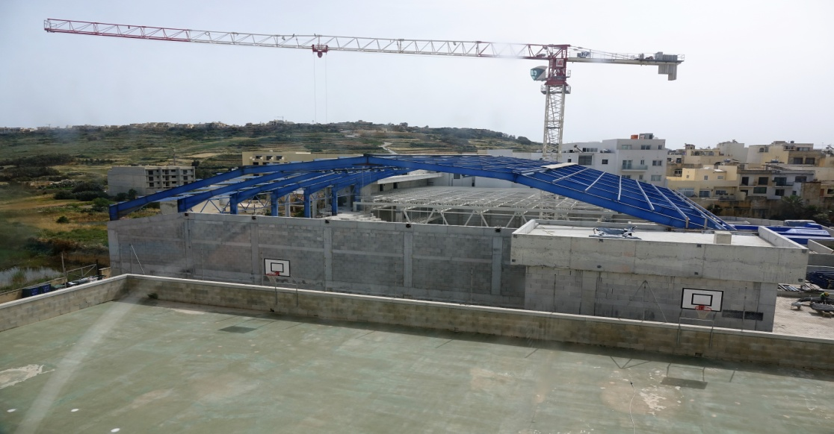
Students here learn English and Maltese as a native language. The second one, as a European language, is related to Arabic. As a foreign language students can choose between Spanish, Italian, German, French and Arabic. When it comes to religion in Malta Christianity is most dominant. The roots of Catholicism are also noticed in schools where attitudes of peace, respect and tolerance are thought
.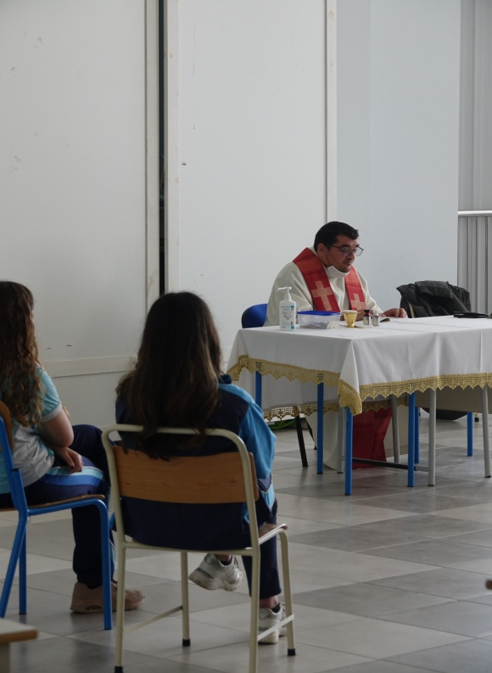 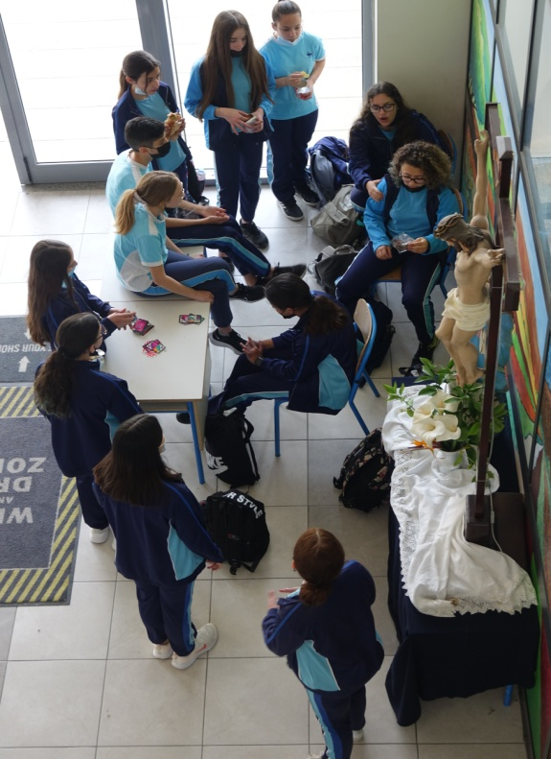
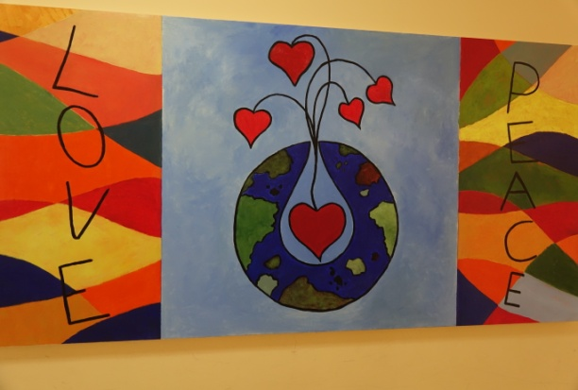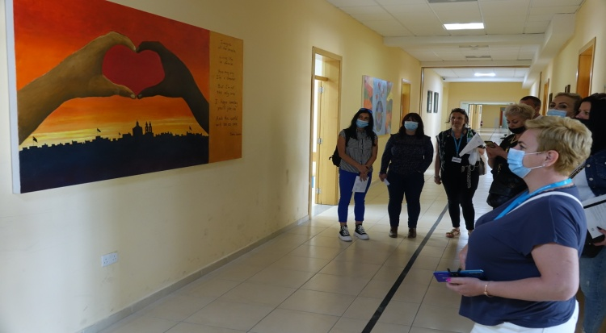
During our stay in Malta we gained a new experience in exchanging information and pedagogical knowledge on an international level. First of all we have improved our own workshop and our language competences.
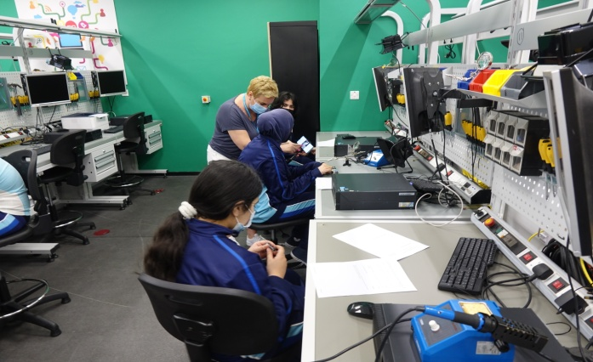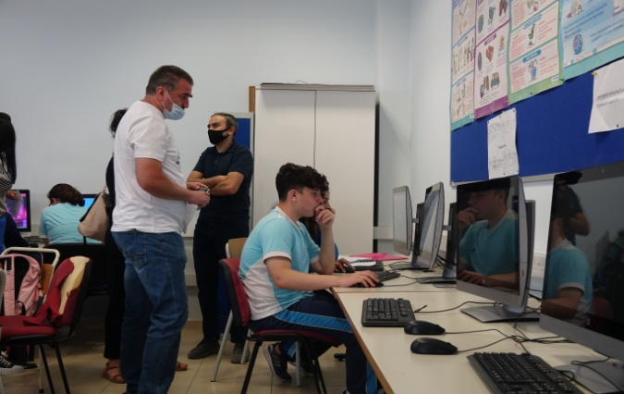

As part of job shadowing, we could observe the use of innovative methods in case of individualization of teaching, the use of multimedia tools and the best ways of working with disabled students using activating methods.
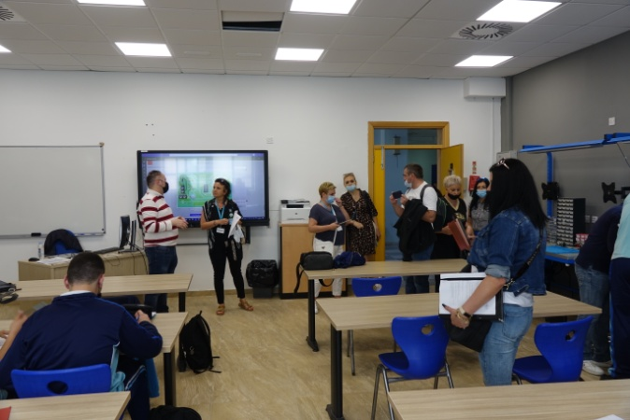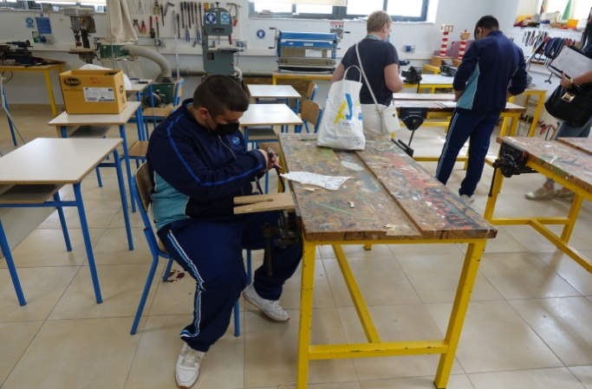
A room that we were really impressed by was the well-equipped school library. It seemed to be a good place to motivate students to read and extend their vocabulary and interest in English and Maltese literature, art and architecture.
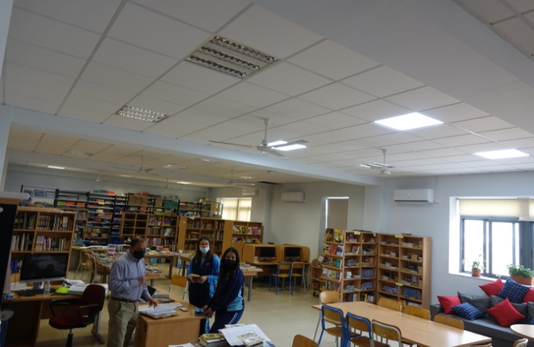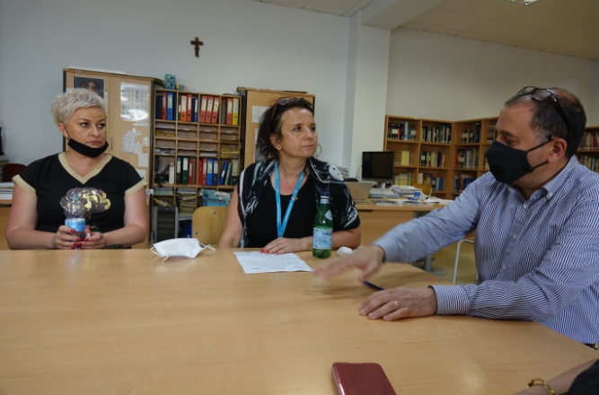
Another point of the schools cooperation was visiting the Gozo Collage Rabat Primary School, that is focused on children in their first period of school education. The school is situated in the historical part of the city of Gozo and was founded in the 19th century. A unique atmosphere and a positive attitude to life are the trademark of the school. It is a place where the superior values are well-being and happiness of the young generation.

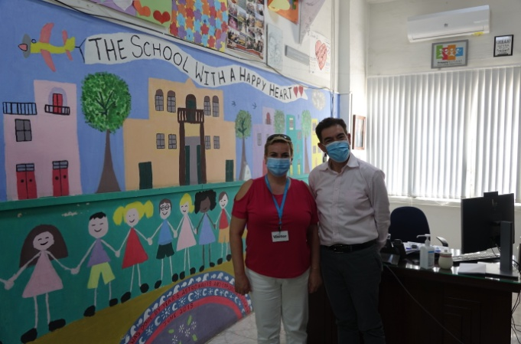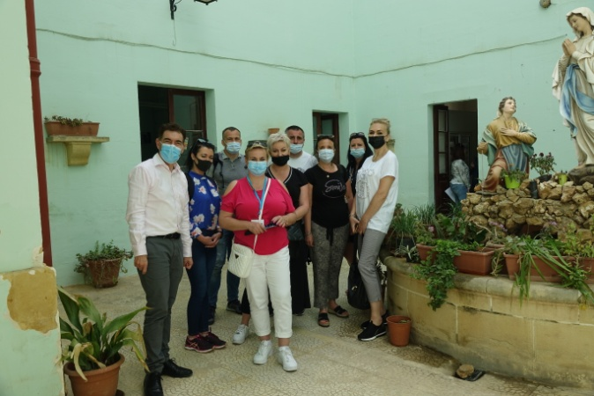

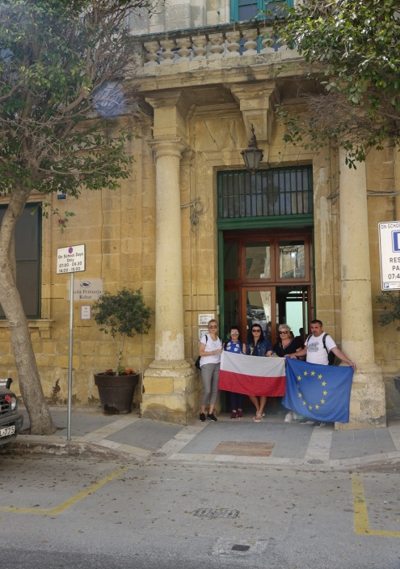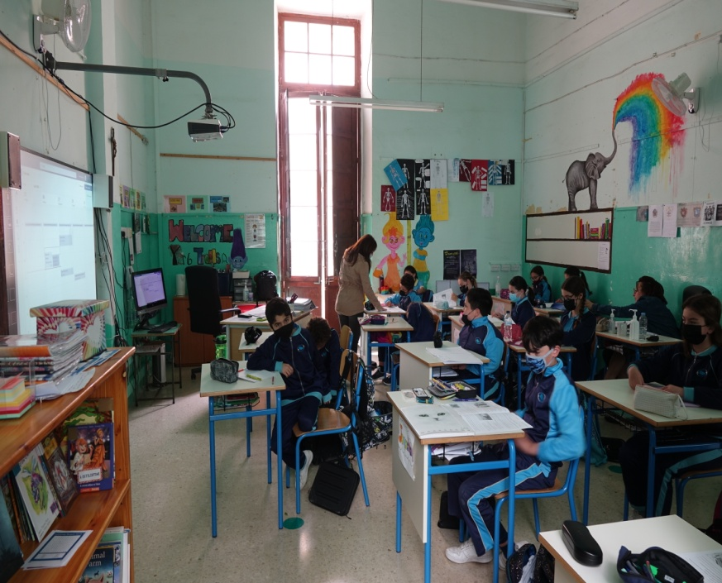

This school is also a good example of an institution where IT is commonly used in the early stage of education.
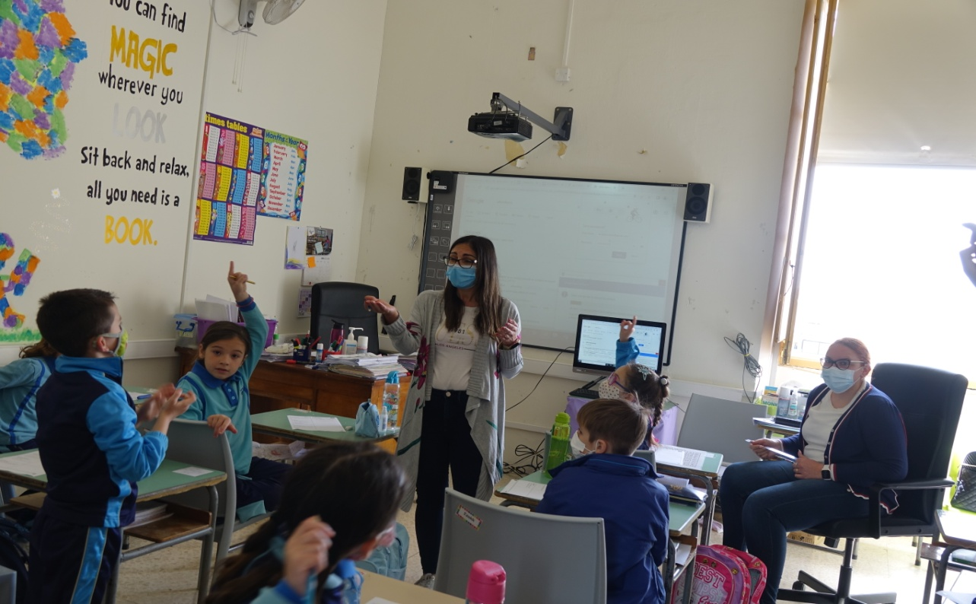
There were also some surprises during our stay in Gozo . Our visit coincided with an event organized for children. The school's guest was Ryan Hili, the winner of the Maltese edition of the X-Factor program. His personality inspires a lot of children by developing their passions and interests.

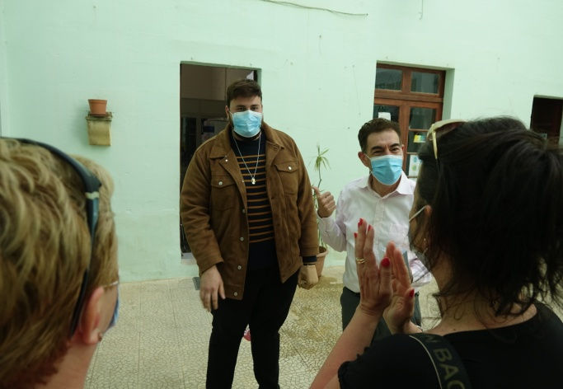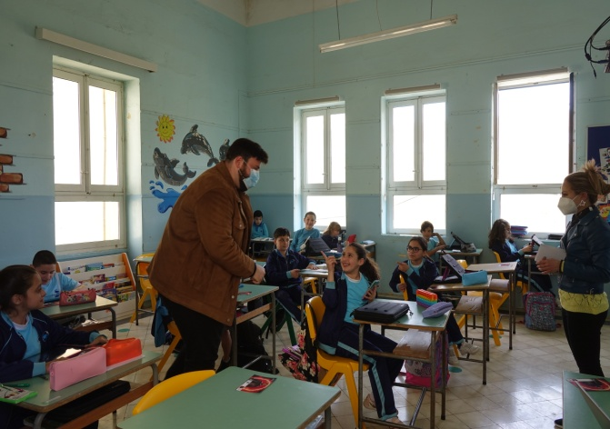

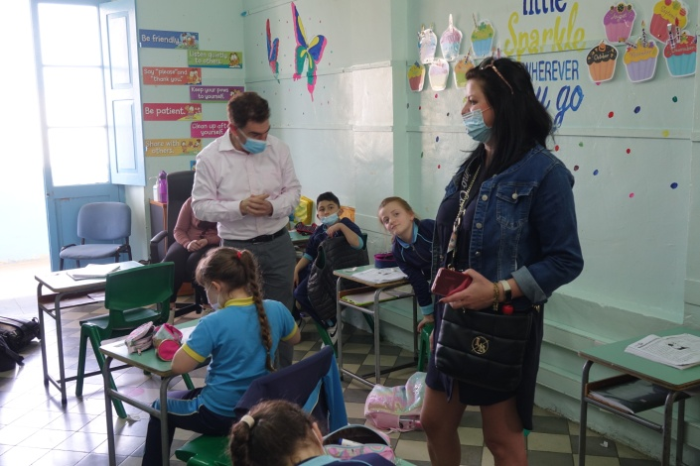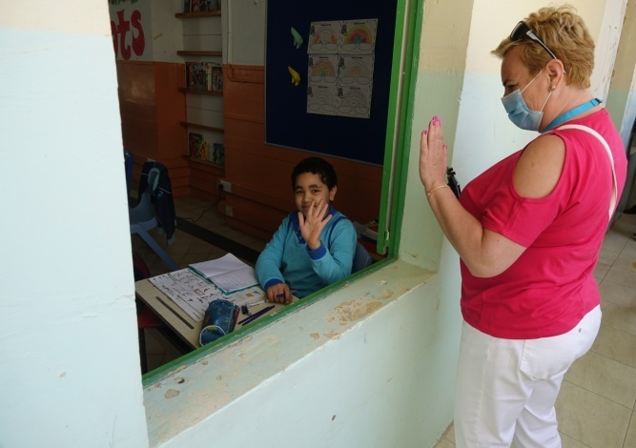

The partner institution also took care of sightseeing aspect. We could get to know culture, architecture and beautiful landscape of the Maltese islands. The Republic of Malta is the smallest country in the European Union and its archipelago consists of three main islands: Malta, Gozo and Comino. The traffic here is left-hand and the typical English red telephone boxes lining the streets.
On the last day we visited Valletta - the capital of Malta and the southernmost European capital on the UNESCO World Heritage List.
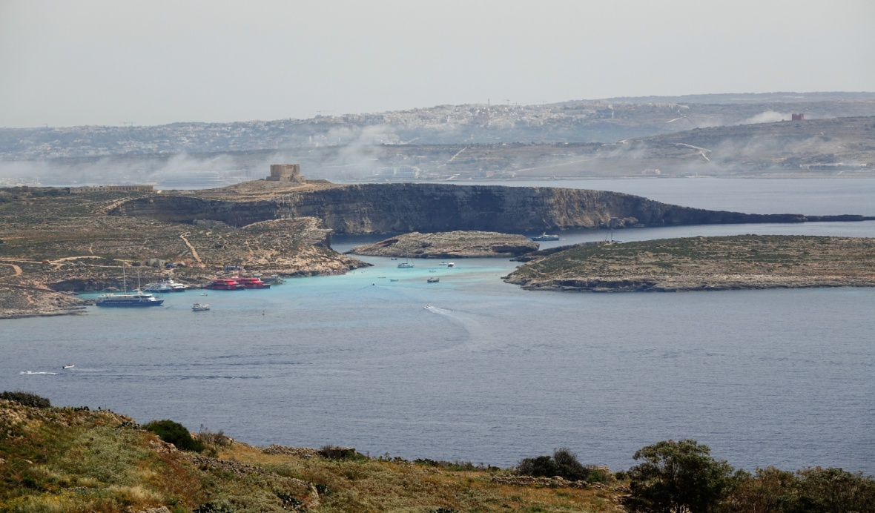
We were walking through the narrow and quiet streets of Mdina - Malta's former noble capital.

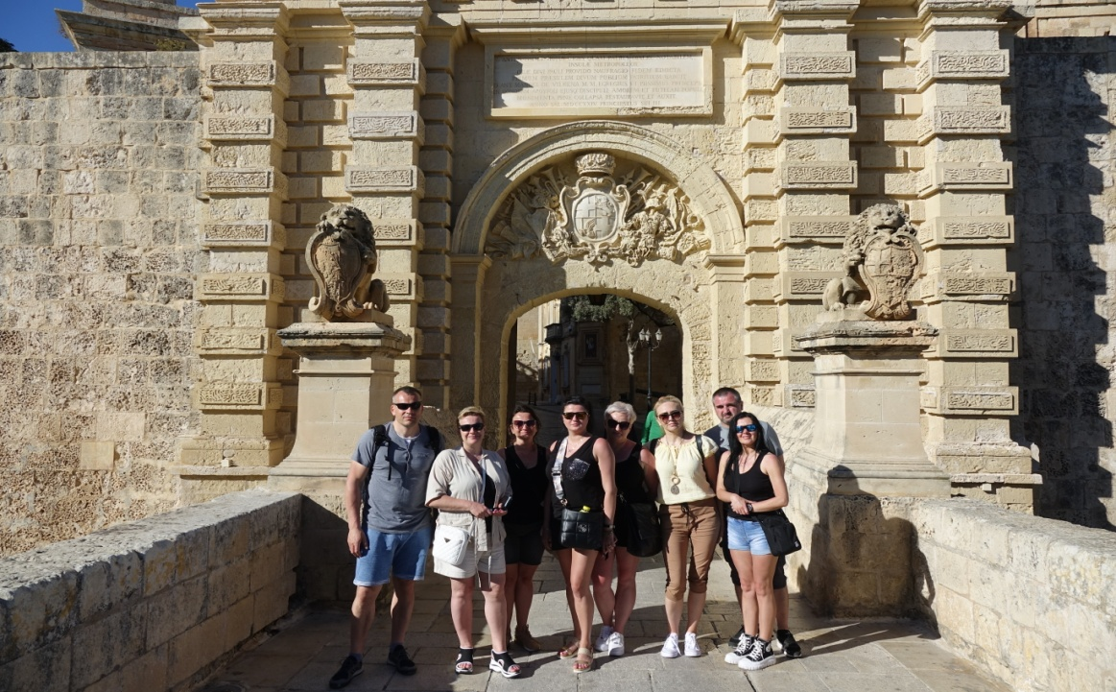

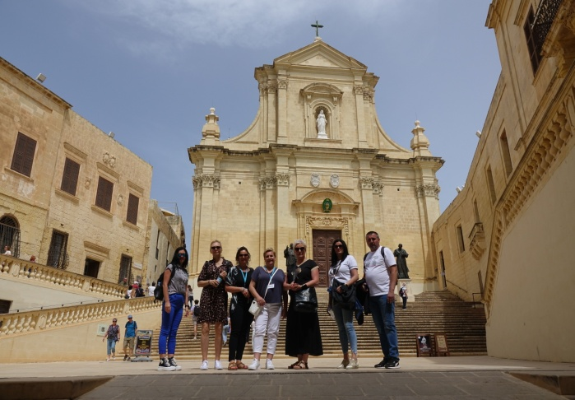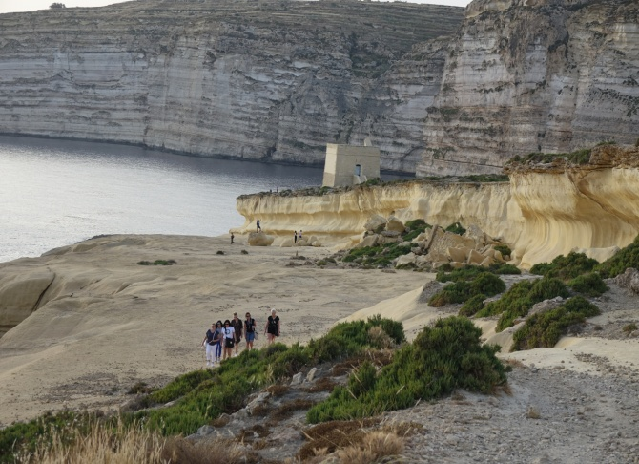
The participation in the project led to acquiring new professional competences. It was also an excellent form of learning and testing our language skills during a stay abroad. We want to pass the acquired knowledge and experience on the colleagues and use it in future projects.
The cooperation and conversations in an international team gave us the opportunity to develop our personal predispositions and overcome language barriers. It is a precious gift that let us feel like a true European citizens.

Tłumaczenie tekstu: Karina Płotkowska

